Rec | Autumn 1  Unit outcome -Using the age related key features of the genre. |  |  |  | Autumn 2 | Spring 1 |  |  | Spring 2 |  | Summer 1  Writing opportunities (short). | Summer 2
Within Reception, children will follow our core book programme alongside other texts that will link with their individual interests and curriculum themes. During the Summer Term the children will follow a more formalised writing curriculum in preparation for transition into KS1.
Writing Root  Text | Theme: Super Me- Powers and talents  Core Books:  Super Milly and the Super School Day  Stephanie Clarkson  Supertato  Colour Monster  Be You!  Funny Bones  Outcomes  Name writing, Join in with songs, Verbal retelling, Initial sounds, letter formation, giving meaning to mark making. |  | Theme: Light and Dark- Diversity  Core Books  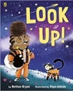  Look up!  Nathan Bryon and Dapo Adeola  Little Glow  The Quiet Little Firework  Owl babies  Outcomes  Name writing, Oral retelling, discussing characters and settings, making comparisons between familiar stories, initial sounds, labels and captions, CVC words. |  |  | Theme: Down in the Woods  Core Books:  Where the Wild Things Are  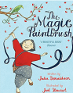  The Magic Paintbrush Julia Donaldson and Joel Stewart  The Gruffalo Julia Donaldson  Little Red Riding Hood  We’re Going on a Bear Hunt  Don’t Wake the Bear Hare!  Outcomes  Character descriptions, setting descriptions, labels and captions, story mapping, CVC and CVCC words, alternative character stories. |  |  | Theme: Ready, Steady, Sow!  Core Books:  The Extraordinary Gardener  The Enormous Turnip  Beans on Toast  Jasper’s Beanstalk  Tad  Outcomes  Forming letters, story mapping, labels, lists and captions, instructional vocabulary, sequencing, introducing features of fiction vs non-fiction.  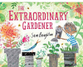 |  | Theme: At Sea  Core Books:  The Night Pirates Pete Harris and Deborah Allwright  Pirates Love Underpants  Clean Up  Shark in the Park  That’s not my Hat!  Outcomes  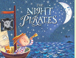  Correct letter formation, letters, labels and captions, Writing an information guide. | Theme: Animals and Habitats  Hairy Maclary from Donaldson’s Dairy Lynley Dodd  Oi! Frog Kes Gray and Jim Field  Elmer  Brining the Rain to Kapili Plain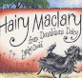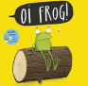  Outcomes:  Correct letter formation, writing a phrase, writing in role, rhyming phrases, alternative stories.
Year 1 | Autumn 1 |  |  |  | Autumn 2 | Spring 1 |  |  | Spring 2 |  | Summer 1 | Summer 2
Writing Root/  Spelling Seed  Text | Cave Baby  Julia Donaldson  -Captions describing an animals  Not A Stick  -Writing Lists  Transcription Skills- Lists and captions  -Letter fornation  -Segmenting to spell  - leaving spaces between words | 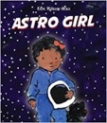  Astro Girl  Ken Wilson-Max  Fact file about astronauts.  -Introduce Capital letters and full stops  -Introduce nouns  - Simple pronouns  Beegu  Alexis Deacon  Character Description  - Simple adjectives  - Captions  - Revisit Capital letters and full stops |  |  |  | Billy and the Beast  Nadia Shireen  Character Descriptions  - Adjectives  - CL and FS  - Sequencing events  - Suffixes ed, full and less  Write a recipe/ List  - Introduce conjunction “and” to join ideas (so/ but)  - Suffix “s” for plural | 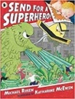  Send for a Superhero  Michael Rosen & Katharine McEwan  Character Descriptions: Wanted posters  Describe using adjectives  Use a range of suffixes  Orally rehearse sentences  Use conjunctions (and, so, but, because)  Begin to use a question mark  Write speech bubbles  Instructions- Linked to topics  - Verbs – past tense  - Writing commands  - Conjunctions |  |  |  |   Yeti and The Bird  By Nadia Shireen  Character Description and Simple Narative  Capital letters and full stops  Nouns, verbs , adjectives and conjunctions  Use sequencing words  Julian is a Mermaid by  Jessica Love  Poetry- Descriptive  Capital letters for proper nouns  Verbs  Adjetcives to describe nouns | The odd egg  Explanation: How to look after an egg  Command sentences  Adjectives to describe  Non-Chronological Report  Fact-file about Eggs  Dragon Post  Explantation- How to look after a dragon  (As above)
Read Aloud Texts  + Any stories to supplement CUSP Curriculum | Room on the Broom  Julia Donaldson  Funny Bones  Alan Alhberg  (May be used for extra transcription work) | How to Catch a Star  Oliver Jeffers  Sidney, Stella and the Moon  Emma Yarlett  Snail in Space  Nadia Shireen  The Comet |  |  |  | We’re going to catch a monster  Malorie Blackman  Milo’s Monster  Tom Percival | Tracion Man  Mini Grey  Super Kind  Claire Freedman  Supertato- Easter  Paul Linnet |  |  |  | Poetry- A range of poetry, expressing likes and dislikes  I want my hat back  Jon Klassen  The Naughty Bus | Here we are  Oliver Jeffers  There’s a Rang-tang in my bedroom  James Sellik
Year 2 | Autumn 1 |  |  |  | Autumn 2 | Spring 1 |  |  | Spring 2 |  | Summer 1 | Summer 2
Writing Root/  Spelling Seed  Text | The Great Fire of London  Emma Adams and James Weston Lewis  Information writing  Letter formation  Capital letters and full stops  Capital letters for Proper Nouns  Common nouns  Note taking  Being verbs- “is, was, had”  Past Tense verbs  Diary Writing  First person  Adjectives to describe feelings  Use co-ordinating conjunctions  Time adverbials |  |  | A Walk in London  Salvatore Rubbino  Persuasive Travel Leaflet  Present tense  Superlatives- er est  Adjectives to describe settings  Command sentences- direct address  Rhetorical questions  Information Travel Guide  Write in 2nd Person  Present tense  Sub-headings  To write noun-phrases  Questions using question marks |  | Wolves  Emily Gravett  Non chronological leaflet  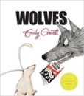  Write questions and statements  -Facts and opionions  -co-ordinating conjunctions  -subordination  -Expanded noun phrases  Character Description: Wolf  (Link to Little Red)  -Expanded noun phrases  -Exclamation sentences  -conjuctions  -Retell a well known story  -Time and place adverbials |  | Jim and the Beanstalk  Raymond Briggs  Fairytale Narrative  Co-ordinating conjucntions  Events in sequence  Adverbials to sequence  Write own narrative based on the story  To edit and improve writing  Explanation Text: Life cycle of a bean  Adverbials to sequence  Subordination  Co-ordination  Use of technical vocabulary |  |  | The Dragon Machine Helen Ward  Dragon Guide- Information/ Explanation  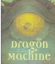  Commands, questions and statement sentences  Conjunctions- Co-ordinating and subordninating  Prepositions  Noun phrases  Commas in lists  Past tense verb forms  Setting Description: Describe a scene  Noun phrases  Place adverbials/ Prepositional phrases  Commas in lists  Write in first person | Toys in Space Mini Grey  Fantasy Setting Descriptions/ Own version narratives  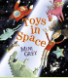  • Sentences with different forms: statement, question, exclamation, command • Expanded noun phrases to describe and specify [for example, the blue butterfly] • The present and past tenses correctly and consistently including the progressive form • Subordination (using when, if, that, or because) and co-ordination (using or, and, or but)
Literary Leaf Text | Rabbit and Bear  Julian Gough and Jim Field  Read aloud Suggestions  Paddigton  The owl who was afraid of the dark  Isadora Moon |  | A book of Bears  Katie Viggers  Read aloud Suggestions:  Hotel Flamingo (Also Reading leaf)  The Christmas Pine |  |  | 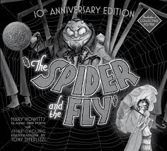  The Spider and the Fly  Mary Howitt and Tony DiTerlizzi  Read aloud:  Lion Girl  The bear and the piano  Pugs of the Frozen North (Chapter) |  |   After the Fall Dan Santat  Read aloud Suggestions:  Goldilocks and the three bears  Cinderella: an art deco fairytale (reading root alt)  (Any alternative fairytales) |  |  | Ada Twist and the Perilous Pants  Andrea Beaty  Read Aloud:  Dear Earth  The boy who grew dragons | Cakes in Space Philip Reeve  Read aloud:  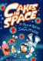  Aliens in the Jam factory
Year 3 | Autumn 1 |  |  |  | Autumn 2 | Spring 1 |  |  | Spring 2 |  | Summer 1 | Summer 2
Writing Root/  Spelling Seed  Text | The Tin Forest  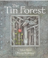  Setting Descriptions  Time, place and cause – adverbs and conjunctions  Expanded noun phrases  Alternative pronouns to avoid repetition  Choose vocabulary for effect  Commas in lists (as well as expanded noun phrases) |  |  | 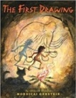  The First Drawing  Mordicai Gerstein  Character Descriptions  Plural nouns  Apostrophes for omission and possession  Fronted adverbials to open sentences  Choosing precise vocabulary  Exclamation sentences |  | Leon and the Place Between  Setting Description  Identifying word class of words  Adverbs to modify a verb  Figurative language to expand nouns  Use of dialogue  Show not tell character feelings |  |  | 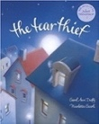  The Tear Thief  Carol Ann Duffy  Letter Writing:  Apostrophes for possession  Use auxiliary verbs  Write in 1st person  Past tense regular and irregular verbs  Time and place adverbials (fronted)  Poetry- Figurative Language  Use metaphors and similes  Thoughtful adjectives and verbs  Repetition and alliteration |  | Escape from Pompeii Christina Balit  Setting Descriptions  - Present progressive tense  - Preposition phrases  - Use senses to describe  - Expanded noun phrases  -Commas in lists    Optional Extra- Write 1st person Diary recounts | Flotsam  David Wiesner  Setting Descriptions  Fronted adverbials  Commas
Literary Leaf Text | 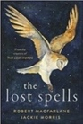  The Lost Spells Robert MacFarlane  Read aloud:  The land of Roar  The last bear | 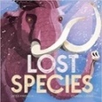Lost Species  Jess French  Read Aloud:  Starfell  The creakers |  |  |  | 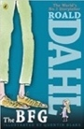  The BFG  Roald Dahl  Roald Dahl- revolting rhymes |  |  | 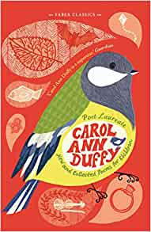  New and Collected Poems for Children  Carol Ann Duffy  Or  The Street Beneath my feet  Read aloud:  Super Nova  The Worst Witch |  | Earth Shattering Events Robin Jacobs  Read alouds:  Sam Wu is Not afraid of ghosts  Charie changes into a chicken  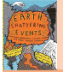 | Adventuremice: Otter Chaos  Read Aloud:  The Highland Falcon Theif  The Nothing to see here Hotel
Year 4 | Autumn 1 |  |  |  | Autumn 2 | Spring 1 |  |  | Spring 2 |  | Summer 1 | Summer 2
Writing Root/  Spelling Seed  Text | The Jabberwocky  Narrative: Character description- wanted poster  -Expanded noun phrases  -Identifying wordclass  -Using adjectives to describe |  | Beowulf  Legend Narrative/ Character Descriptions  Possesive apostrophes  Prepositional phrases  Expanded noun phrases  Paragraphs panning a character  Dialogue- inversted commas  Kennings Poems  Modifying verbs –er, ed  Writing to a given form |  |  | Explanation Texts – Linked to Science  -Subordinate conjunctions- cause and effect  -co-ordinating conjunctions  - Formal language/ Precise vocabulary  -Fronted adverbials  -commas in lists |  |  |  | 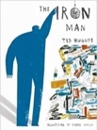  The Iron Man  Ted Hughes  Diary Writing:  First person  Apostrophe’s for contraction  Alternate chapters- Character description focus | Diary Entries  - Causal Conjunctions  - Synonyms- shades of meaning  - Present perfect tense  - Adverbs of time and place  - Fronted adverbials  - Paragraphing  Setting Description: In first person recount | The Story of Tutankhamun Patricia Cleveland -Peck  Non-Chronological Reports- Egyptian Gods  Subheadings  Pararaphing  Co-ordination  Subordination  Narative: Entering the tomb- Marcy and the Riddle of the Sphinx Extract  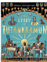
Literary Leaf Text | Read Aloud: Grimwood |  | Zombirella Joseph Coelho  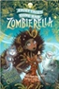  Read Aloud: Viking Boy/ Loki |  |  | Norse Myths Kevin Crossley-Holland  Read Aloud: The Great Chocoplot/ Wonder Brothers |  |  |  | 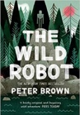  The Wild Robot  Peter Brown  Read Aloud: Podkin One Ear/ How to Train Your Dragon | Poems from a Green and Blue Planet Sabrina Mahfouz  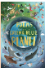  Read Aloud: Max and the Millions/ Varjack Paw | Skygazing  Anna Claybourne and Kerry Hyndman  Read Aloud: Griffingate/ Explorer

Year 5 | Autumn 1 | Autumn 2 |  |  | Spring 1 | Spring 2 | Summer 1 | Summer 2
Writing Root /  Spelling Seed  Text | 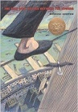  The Man Who Walked Between the Towers  Mordicai Gerstein  Biography/ autobiography  Key Objectives: |  | Persuasive writing- Formal and Informal  Conjunctions to give reason  Use of facts and opinions  Superlatives  Contractions vs no contractions  1st , 2nd and 3rd Person  Expanding nouns  Questions, statements and commands  Frindleswlyde  Descriptive writing- Setting Descriptions including Poetry using figurative language  Personification  Similes and metaphors  Fronted adverbials with commas  Expanded noun phrases  Paragraphing- changing time or place |  | .Robot Girl  Malorie Blackman  Science-fiction narratives  Synonymns- shades of meaning  Punctuating dialogue  Expanded noun phrases | Explanation Text  OR  High Rise Mystery  Narrative- Building suspense  Use of short sentences  Figurative language techniques  A range of adverbials  Use a range of cohesive devices | The Tempest ?  Narrative- Portray character through dialouge and action  Inverted commas and punctuation in speech  Modal verbs  Fronted adverbials to move on action  Relative clauses to describe (parenthesis) | Percy Jackson  Rick Riordan  Mythical Narrative  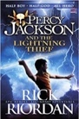  Dialogue to advance action  Questions, commands or statements  Changing mood- pathetic fallacy  Hyphens- to add detail  Prepositions
Literary Leaf Text | 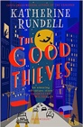  The Good Thieves  Katherine Rundell |  |  |  | 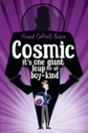Cosmic Frank Cottrell Boyce | Real-life Mysteries Susan Martineau and Vicky Barker (D.W. group)  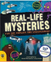 | New and Collected Poems for Children  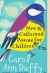  Carol Ann Duffy  (S.K. group)
Year 6 | Autumn 1 |  |  | Autumn 2 | Spring 1 | Spring 2 | Summer 1 | Summer 2
Writing Root /  Spelling Seed Text | 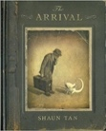  The Arrival  Shaun Tan  Extended own version narrative- Character Description | Explanatory Texts- Circulation, Volcanoes, Earthquakes  - Paragraphing to link ideas  - Headings, Sub-headings and cohesive devices  - Passive Voice  - Formal tone  - Subordinate clauses- subordinate conjunctions  - Parenthesis |  |  | 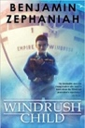Windrush Child  Benjamin Zephaniah  Letters formal and informal  -Modal verbs  -Writing informally  -Dashes and semi-colons  -contrasting conjunctions  -Subjunctive form#  -Figurative language  -Relative clauses  -range of adverbials | 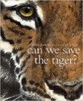Can We Save the Tiger?  Martin Jenkins  Discussion Text  -Subjunctive form  -Modal verbs  -Commas to demarcate clauses  - Varying position of subordinate conjunctions  -Write multi-clause sentences  -Prepositional phrases  - Semi-colons and colons  -Parenthesis, using punctuation for effect  -Main clause and subordinate clause  -Formal tone | The Wind in the Wall Sally Gardner  Extended narrative -Setting Descriptions  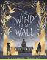  -Figurative language techniques  - A range of noun phrases  - Use of colons  -Subjunctive form  - Repetition for effect  -Adverbial phrases  -Passive voice  -Past participles  - Convery character through speech  - Change in tense- flashback | Fairytales  Shakespeare``````    Transition Work
Literary Leaf Text | 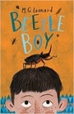Beetle Boy  M. G. Leonard | 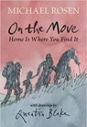  On the Move: Poems about Migration  Michael Rosen |  |  | The Tiger Rising  Kate DiCamillo  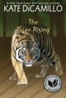 |  | Revision of Comprehension skills based on Past papers:  Ordering events, select and retrieve, impressions, using evidence, summarising and making inferences.